

Draw It or Lose It

# **CS 230 Project Software Design Template**

Version 1.2

## Table of Contents

**CS 230 Project Software Design Template**1

**Table of Contents**2

**Document Revision History**2

**Executive Summary**3

**Design Constraints**3

**System Architecture View**3

**Domain Model**3

**Evaluation**3

**Recommendations**5

## Document Revision History

| Version | Date | Author | Comments |
| --- | --- | --- | --- |
| 1.0  1.1  1.2 | 03/16/2021  04/01/2021  04/14/2021 | Omar Al Yousuf  Omar Al Yousuf  Omar Al Yousuf | First template for the game design  Adding platforms evaluation  Adding platform Recommendation |

## Executive Summary

My name is Omar Al, Technology Consultant at Creative Technology Solutions (CTS), and I will be developing a web-based game called “Draw it or Lose It” that is already available as an Android app to possibly make the game support multiple platforms such as Mac and Windows.

## Design Constraints

* The game will have to be a web-based to allow cross multiplayers between the three major platforms mac, Linux, and windows in addition to Android and IOS mobile devices.
* Game and team names must be unique to allow users to check whether a name already exists or available to add. This can be accomplished using the “iterator pattern” to iterate through the available data and return a match or add the new name
* Only one instance of the game can exist in memory at any given time. This can be done by using a java pattern called “singleton pattern” to make only one instance of the class exists in the memory. Therefore, by creating unique identifiers for each instance of a game, team, or player.

## System Architecture View

Please note: There is nothing required here for these projects, but this section serves as a reminder that describing the system and subsystem architecture present in the application, including physical components or tiers, may be required for other projects. A logical topology of the communication and storage aspects is also necessary to understand the overall architecture and should be provided.

## Domain Model

The Entity class is the base class in this UML. The three classes Game, Team, and Player inherit all the attributes and methods of the Entity class presenting one of the OOP principles called “Inheritance”. Another OOP feature utilized in this UML is Encapsulation, for example, this principle is illustrated in the Entity class section where the class attributes are private which means they cannot be accessed by other classes and methods. The diagram also shows how the ProgramDriver class uses the SingletonTester class to prove there is only one instance. Aggregation was also implemented to allow all classes to have a reference on one another.

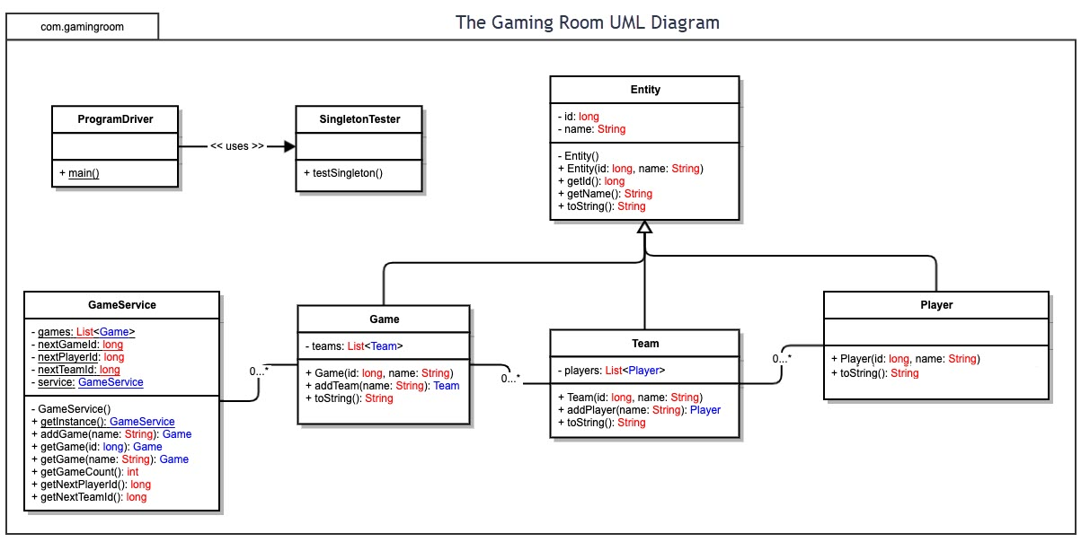

## Evaluation

Using your experience to evaluate the characteristics, advantages, and weaknesses of each operating platform (Linux, Mac, and Windows) as well as mobile devices, consider the requirements outlined below and articulate your findings for each. As you complete the table, keep in mind your client’s requirements and look at the situation holistically, as it all has to work together.

In each cell, remove the bracketed prompt and write your own paragraph response covering the indicated information.

| **Development Requirements** | **Mac** | **Linux** | **Windows** | **Mobile Devices** |
| --- | --- | --- | --- | --- |
| **Server Side** | -Flexible terminal commands to host the server.  -According to the Apple website, the cost for a macOS server is starting at $19.99. | -Complex terminal commands however costs less than Mac as Linux is an open-source server and has multiple distributions available that are usually available for no cost.  -Might requires some additional training since not many people are familiar with Linux | -Many software tools available to host and manage a server compared to other OSs.  -Easy to setup server using a GUI interface and offers hands-on support for new users. | A mobile application is more suitable than web-based software due to the size of mobile devices, also mobile devices not as powerful as computers utilized on other platforms. |
| **Client Side** | -Safari is the main browser for most Mac users, it also supports Chrome and Firefox  -Cost is less when compared to Linux.  -Mid level of expertise  -Moderate time needed | -Firefox is the go-to browser for Linux  -Cheapest between the other three platforms if not free  -Requires a high level of expertise  -Maximum time | -Edge comes standard with windows but not many users utilize it. The most common ones are Chrome and Firefox  -Cheaper than Mac  -Minimum expertise  -minimum time | -Safari is most common for iPhones and iPad devices.  -Cheap since there are many available  -minimum expertise  -moderate time |
| **Development Tools** | -Swift is the most common language in Mac and has many IDEs available. The Apple Developer Program fee is $99.  -Eclipse  -GitHub  -IntelliJ  -Notepad++ | -Atom IDE is the most common for Linux development and it's free of charge.  -Eclipse  -GitHub  -IntelliJ  -Visual Studio | -Visual Studio is great for developing HTML. Professional license costs run between $45-$250.  -Eclipse  -GitHub  -IntelliJ  -Notepad++ | IOS applications are developed using Mac OS with Swift. The Apple Developer Program fee is $99. |

## Recommendations

Analyze the characteristics of and techniques specific to various systems architectures and make a recommendation to The Gaming Room. Specifically, address the following:

1. **Operating Platform**: I recommend utilizing Windows OS for building the game as it supports sufficiently many of IDEs and it’s relatively cheaper than other platforms.
2. **Operating Systems Architectures**: Windows utilizes the Windows API that is implemented to create Windows applications. This service utilizes C and C++ programming languages that enables applications to provide GUI (Graphical User Interface), networking, webservices, and so on.
3. **Storage Management**: Today’s Windows OS contains Desk Management which allow us to add new drives using internal or external hard drives or SSDs and shrink partitions of a current drive. In addition, there are many storage options available to expand Windows devices such as HHD, typical SSD, and M.2 SSD.
4. **Memory Management**: Since the game is a web-based and relatively simple application, it will utilize a small space of the RAM when its running, however, a minimum of 4GB RAM is recommended.
5. **Distributed Systems and Networks**: To have the game support and playable by different platforms, we will utilize a cross platform game engine called Unity. The engine currently supports building games in many operating systems such as Windows, macOS, Linux and mobile devices. It is also important to pick a good healthy server and browser that will be able to handle high volume of online players and teams.
6. **Security**: Since the game is a web-based application, it is necessary to utilize a web-based security platform such as WebARX for protection and monitoring, as well as keep the software up to date.